 | Year 12 ATAR Physics 3 2017  Experiment & Validation Equilibrium 6.0%  NAME: ………………………………………………….  Data: See Data Sheet  Approx. marks shown.

PART A EXPERIMENT (00 marks)

AIM: (a) To measure the forces within a cantilever system.
(b) To assist in understanding static and rotational equilibrium.
(c) To use the Principle of Moments to determine the mass of the boom (ruler).

EQUIPMENT:
• data logging software
• force probes (0-50N)
• 50 cm ruler
• 2 retort stands with a brace
• protractor
• sticky tape, string and scissors
• slotted masses (20 g — 300 g)

METHOD:
- Set up the apparatus as shown. For this system keep the string at right angles to the ruler. Ensure that force probes and string are in all aligned and record the angle θ between the ruler and vertical.

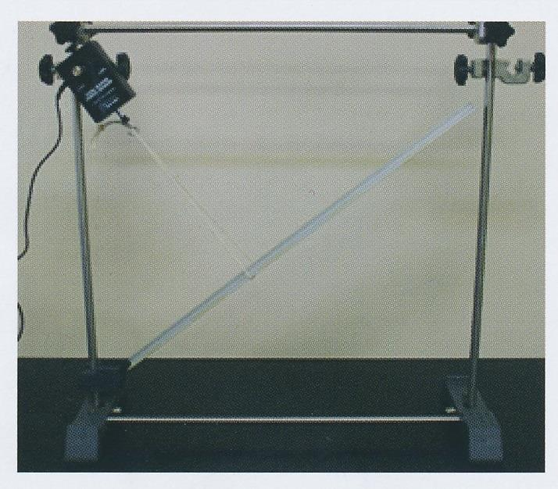 | 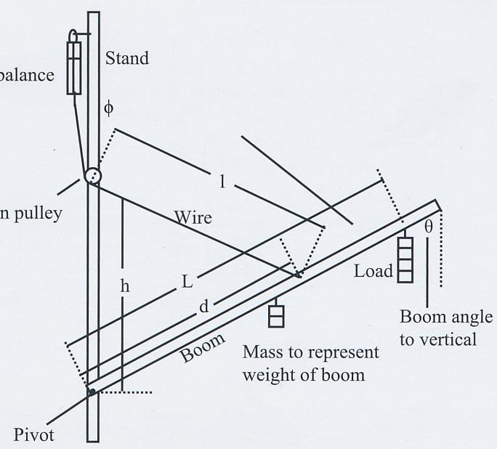  String  r

- Add a 100 g slotted mass to the end of the 50 cm ruler. Record the tension from the force probe.
- Progressively move the load of 100 g mass from the end of ruler to the pivot. Record the tension in the string every 5 cm.
- Repeat steps 2 and 3 for the load of 200 g mass.
RESULTS:

angle θ =…………………...

Load = ………………………g

Weight of the Load (Wt or F_{g}) = ……………………………………………….. N

Table 1
Distance from the pivot along the ruler  L (m) | 0.50
Tension from the force probe
(N)

PROCESSING the RESULTS:

At equilibrium, the sum of the anticlockwise moments = the sum of the clockwise moments

Hence T x r = Wt of load x d₁ + Wt of ruler x d₂

This follows the relationship y = m x + c

- Complete Table 2. There is space for your working at the bottom of this page.

Table 1
T x r
(Nm)
Wt of load x d₁
(Nm)

- Graph T x r vs Wt of load x d₁ for the given load. Draw the line of best fit.

- From the graph determine the equation of the line of best fit. Show your working clearly.

...........................................................................................................................................

...........................................................................................................................................

...........................................................................................................................................

...........................................................................................................................................

...........................................................................................................................................

- Using the equation of the line of best fit, and graph theory, determine the mass of the ruler.
Show your working clearly.

...........................................................................................................................................

...........................................................................................................................................

...........................................................................................................................................

...........................................................................................................................................

...........................................................................................................................................

...........................................................................................................................................

...........................................................................................................................................

CONCLUSION:

What trend or relationship do you observe in the graph of tension vs position of the Load?
Consider the Aim of the experiment.

...........................................................................................................................................

...........................................................................................................................................

...........................................................................................................................................

...........................................................................................................................................

...........................................................................................................................................

...........................................................................................................................................

...........................................................................................................................................

...........................................................................................................................................

...........................................................................................................................................

ERRORS:

Discuss the errors involved in this experiment.

...........................................................................................................................................

...........................................................................................................................................

...........................................................................................................................................

...........................................................................................................................................

...........................................................................................................................................

...........................................................................................................................................

